Washing Dishes Name ____________________________ Date _____________

Carl is working Saturdays as a dishwasher at the restaurant “Ticonderoga”. The salary for the job is $7.50 per hour, but waiters at “Ticonderoga” give dishwashers a portion of their tips each hour. Waiters don’t receive many tips when the restaurant first opens but they receive a lot at the end of the night. His boss said he will usually receive $2 Dollars of tips after the first hour of a shift, then $4 Dollars of tips after the second hour, then $6 Dollars, $8 Dollars, and so on the restaurant gets busier.

How much would he expect to get paid during the 3rd hour of a Saturday shift?

Explain how you know:

___________________________________________________________________________________

___________________________________________________________________________________
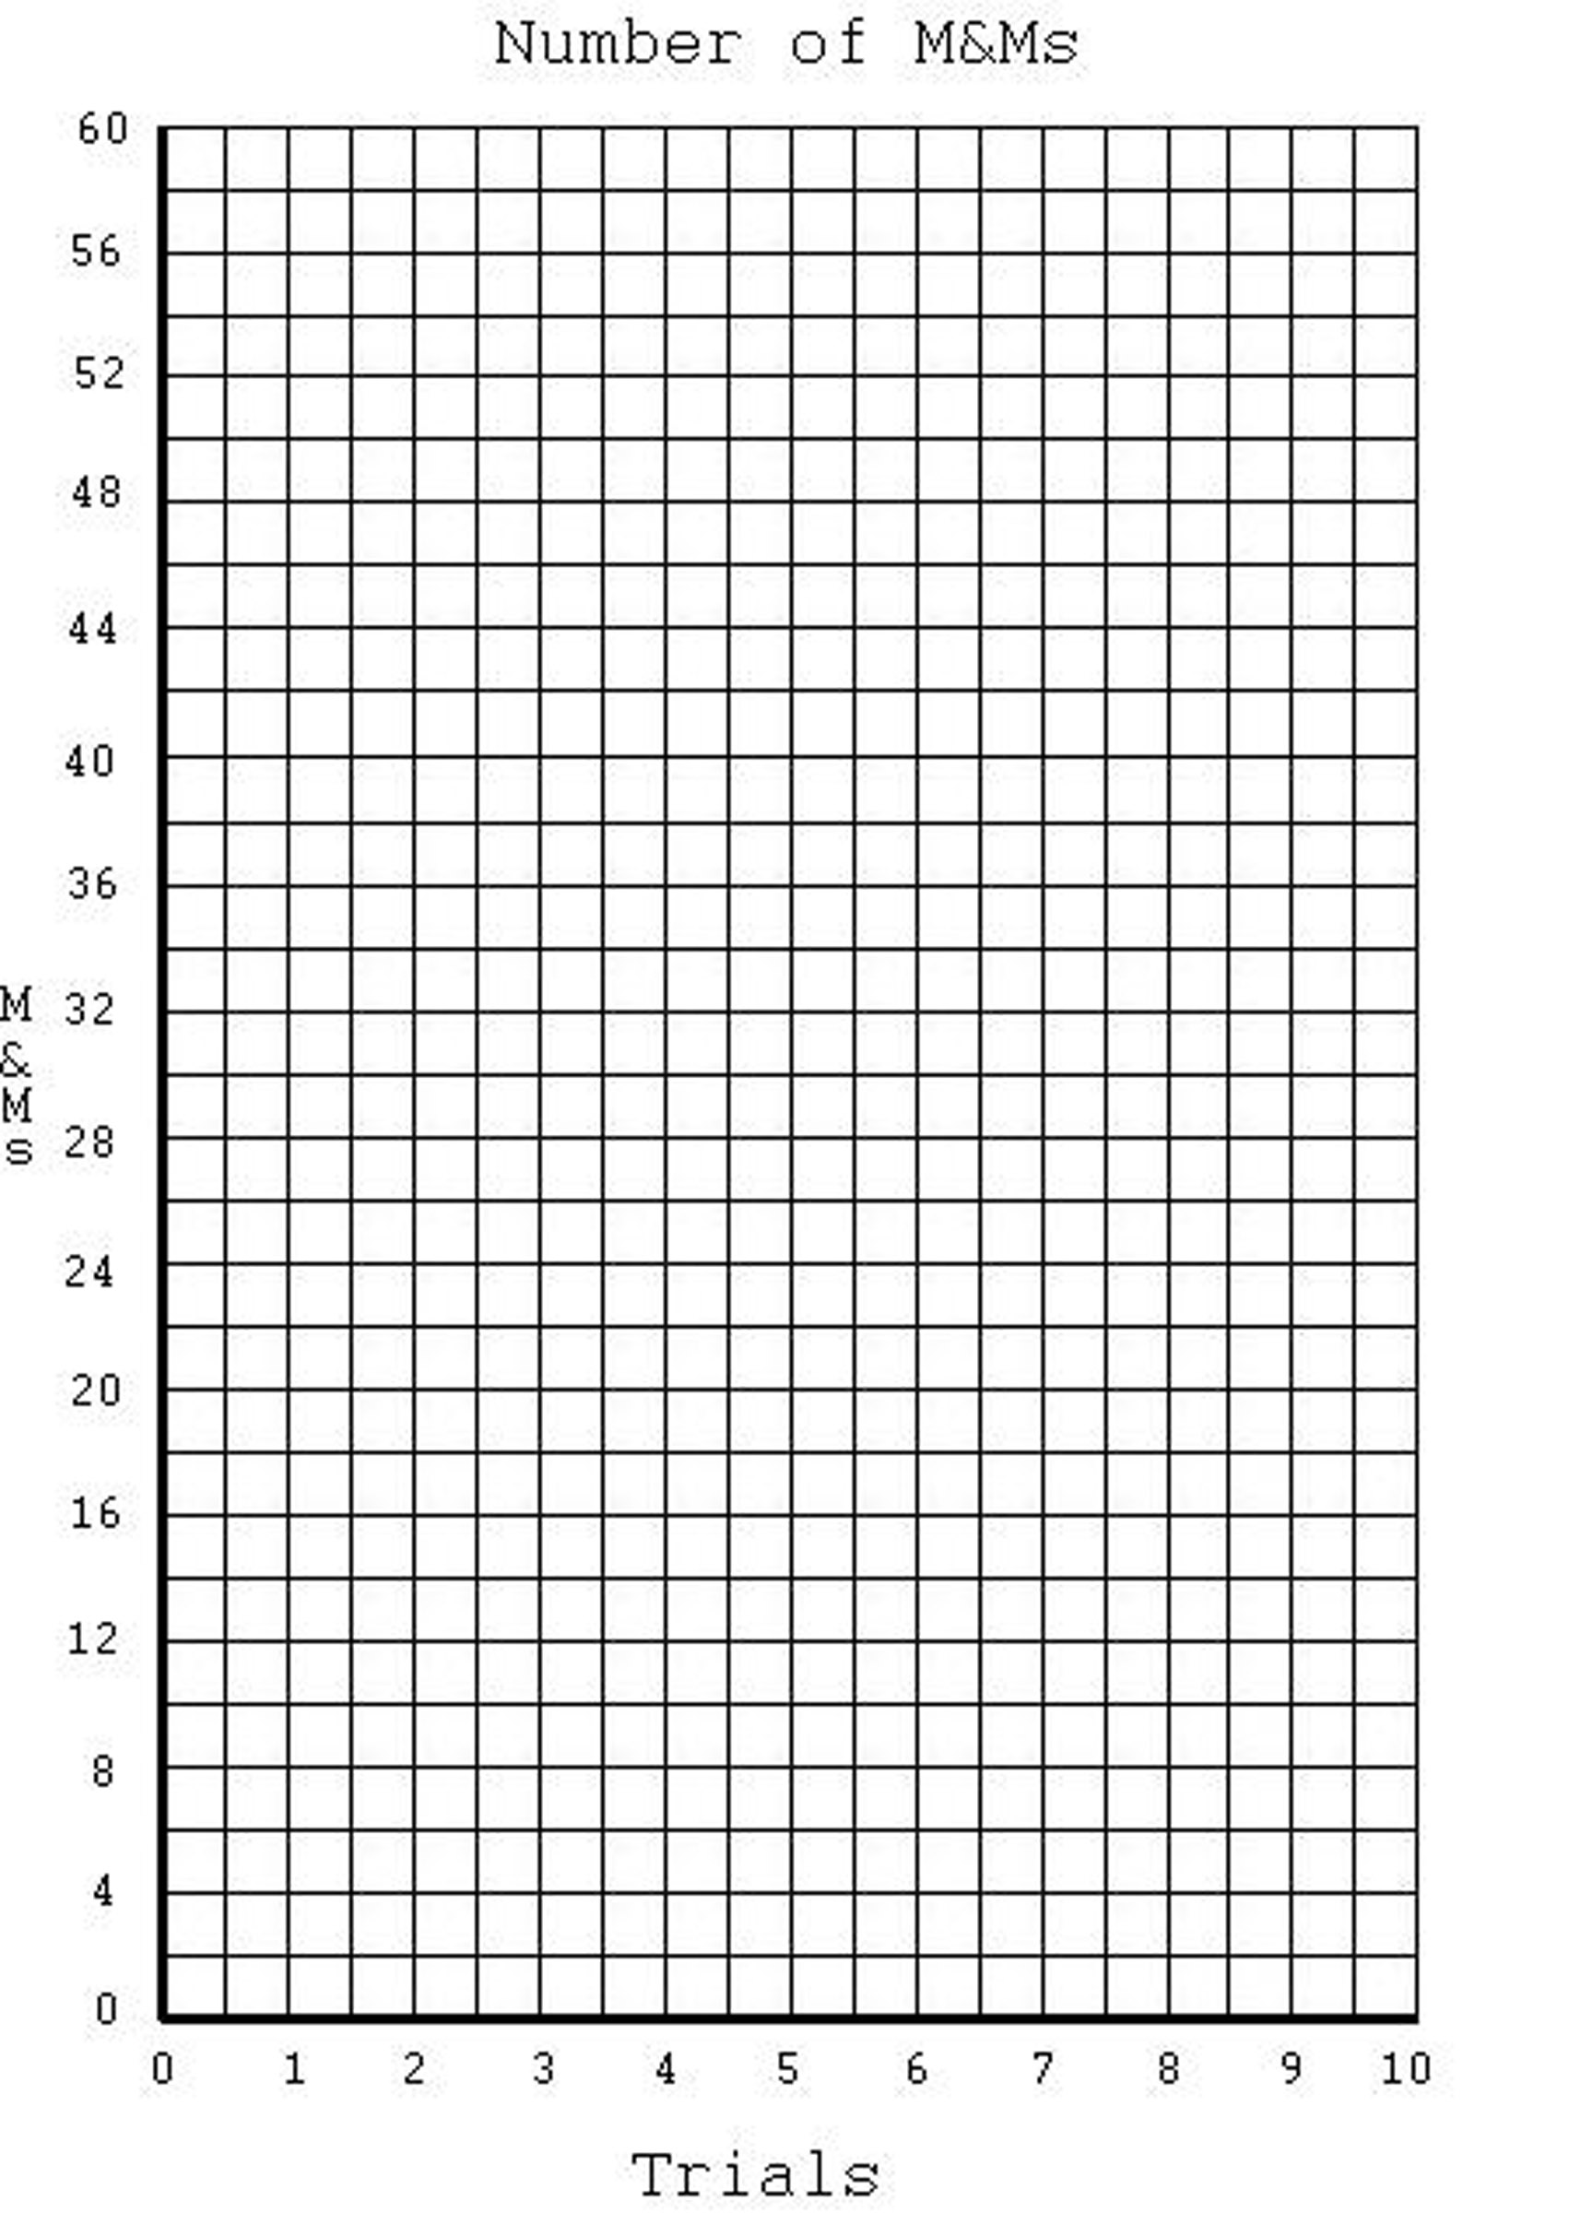
Use a table and a graph to display how much he would make per hour during the 1st, 2nd, 3rd, 4th, and 5th hours?

What kind of function is the relationship between hours and pay rate? Can you make an equation for it?

___________________________________________________________________________________

___________________________________________________________________________________
Washing Dishes Cont’d
Now it’s Saturday and he is excited to start getting the money he needs to buy chipotle, get his little sister the new Call of Duty game, and buy a new iPad. Unfortunately his boss still hasn’t told him how long he is going to be working. It could be 1 hour or it could be 10 hours. He also has to pay $24 out of his check for his uniform

What would his final pay be if he is sent home after the 3rd hour that he works? Explain how you know.

___________________________________________________________________________________

___________________________________________________________________________________
Use a table and a graph to display how much total he would make for the 1st, 2nd, 3rd, 4th, and 5th hours?

What kind of function is this? Make the function below and explain how you know.

___________________________________________________________________________________

___________________________________________________________________________________
How many hours do you think he should work in order to buy Chipotle? Call of Duty? An iPad? Explain.

___________________________________________________________________________________

___________________________________________________________________________________

