If you received this application it means you may be selected to appear on “Illest Road Trip of All-Time.” IRT is a new show where groups of people get $10,000 for a road trip that will be a “unique, life-changing, and eminently watchable experience”. The money you spend will mainly go towards two things your vehicle (rental and gas), and your daily expenses (Hotel and Food). Plan carefully, groups who do not plan to spend at least $9500 of the money will not be considered.

The possibilities for your trip are limited only by your ability to budget the money. MTV can drive it’s production vans anywhere in North America and has relationships with gas stations, hotels, and restaurants to provide you with what you need to finish your journey. You can take as many as you wish stops as long as you start and finish in New York City. You could take a trip as short as 1 week or as long as 31 Days. You can use the money on a solo drive from the beaches of Cancun to the Mountains of Alaska and stop by California on your way back. The trip cannot go across the Atlantic Ocean to Europe, or across any other body of water, because a “Road Trip” needs to take place on an actual road, not a boat. You can also use your money to take up to 7 of your friends on a lavish trip up and down the Jersey Shore.

MTV wants to support an impressive and detailed trip, and one of the most important things to show, is that you can manage the money well. That means you need your trip to fall between $9,500 and $10,000. As long as the ideas are well thought out, MTV will consider any proposal.

Application Abstract
Who will attend the trip? Bring up to 7 other people. On the lines below write the names of your friends, family, and even famous celebrities (MTV can pull strings):

1. _______________________________ 2. _____________________________
Your Name

3. _______________________________ 4. _____________________________

5. _______________________________ 6. _____________________________

7. _______________________________ 8. _____________________________
Part I. Expenses
Expenses - Your main expenses for this trip, outside of the car, will be food and lodging, which are calculated separately. MTV will provide you with three different types of Food and Lodging.
Food:
 $200/day per person  $100/day per person  $25/day per person
High Quality Cuisine Healthy nutritious meals Dollar Menu items
in Fancy Restaurants in family-style diners in fast-food joints

Lodging:
Luxury Suites $500/day - up to 8 people in each Luxury Suite
Hotel Rooms $100/day - up to 4 people in each Hotel Room
Campground $25 /day - up to 4 people at each campground

Baggage:
Designer Brand Luggage $300 for each person
High Quality Duffel Bags $75 for each person
Plastic Bags / No Luggage $0 for each person

Using this information what type of food and lodging would you like to choose and why?
______________________________________________________________________________
______________________________________________________________________________
______________________________________________________________________________
Given the number of people that are going on the trip, what is the total amount you will you spend on food and lodging each day?
_______________________
Total Food & Lodging Per Day

Given the number of people that are going on the trip, what is the total amount you will you spend on luggage for everybody?
_______________________
Total Baggage Expense

Now use the amount you spend on Daily expenses to make an equation in y = mx + b form that will give you the expenses (y) for any given amount of days (x).

Total Expense equation: ________________________
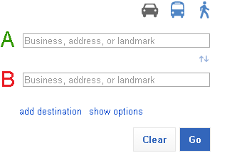
Part II. Route
Create a Map for your trip using Bing Maps (http://www.bing.com/maps).
- Go the website
- Click ‘Get Directions’
- Enter your starting address in NYC
- Enter your destination(s)
- Click ‘Add to route’ before writing in your next destination you want to include more places
- If you have more destinations, enter each and click ‘Add To route’ each time.
- When finished, click ‘Add To Route’ one final time and enter your ending address in NYC
- Click ‘Get Directions’
- Look over your route, if you want to change it, Click ‘Edit Route’ in the top left
- Once your route is good, write down the information about your route below

______________________________________ ________________________
______________________________________ Miles
______________________________________
______________________________________ ________________________
______________________________________ Hours
______________________________________
______________________________________
______________________________________
If MTV only allows people to drive at maximium 10 Hours each day. What is the smallest number of days you could spend driving?

If your trip ends up being 31 days, and you spread the driving out over each day, how many hours would you spend driving each day?
Part III. Vehicle Expenses
MTV will allow you the free use of the following vehicles for your trip because they have product placement deals. Make sure you have enough room for all of your passengers. Pay attention to the Miles Per Gallon (MPG), you will have to pay for gas as well.
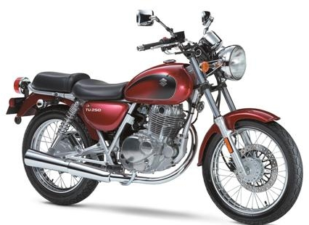 | 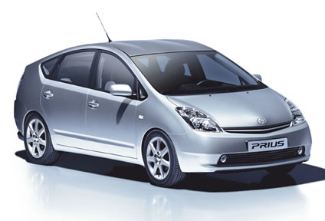 | 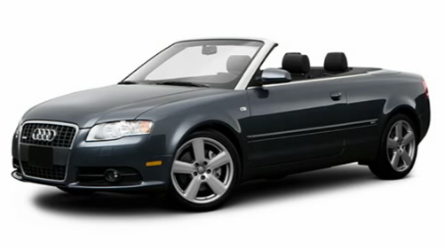 | 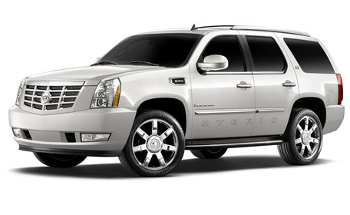 | 
Suzuki TU250x  $22/Day  2 Passengers  70/82 MPG  CITY/HWY | Honda Prius  $34/Day  4 Passengers  51/48 MPG  CITY/HWY | Audi A4 Cabriolet  $67/Day  4 Passengers  21/29 MPG  CITY/HWY | Cadillac Escalade Hybrid  $98/Day  8 Passengers  21/22 MPG  CITY/HWY | Lamborghini Murcielago*  $160/Day  2 Passengers  8/13 MPG  CITY/HWY
What type of vehicle did you choose and why?
______________________________________________________________________________
______________________________________________________________________________
______________________________________________________________________________

Once you choose a vehicle, use the MPG to find out how many gallons it will take you to finish your trip. (Total miles divided by MPG)

___________________________
Gallons of Gas Needed

MTV will have gas available throughout the trip at their corporate rate of $2.80/gallon. How much will your total cost on gas be? (Gallons times $2.80)

___________________________
Cost of Gallons of Gas Needed

Now use the amount you spend on the Vehicle Rental and on Gas to make an equation
in y = mx + b form that will give you the expenses (y) for any given amount of days (x).

Total Vehicle Equation ___________________________
Part IV. Calculating Costs
Use the equations to calculate the cost of a 1, 2, 3, or 4 week trip. Write your results in the table, show your work for at least one example below.
Days | Vehicle Cost - (Check Part IV)  Y=____________________________ | Food and Lodging Cost - (Check Part I)  Y=______________________________ | Total Cost
7
14
21
28
Show your work below

If you can’t find a suitable trip in the table above, then you should be able to use the tables below to determine what the longest possible trip could be. REMEMBER THE TRIP MUST BE BETWEEN $9,500 AND $10,000. Try different lengths of trips in the spaces below.
Days | Vehicle Cost - (Check Part IV)  Y=____________________________ | Food and Lodging Cost - (Check Part I)  Y=______________________________ | Total Cost
It might be that no length trip would work, if that is the case adjust your equations by choosing different values for hotels, cars, food, etc. Then, go through and total up all these equations again. Additionally, if you had to change any of your equations explain your changes below.
______________________________________________________________________________
______________________________________________________________________________
______________________________________________________________________________
Graph two equations or the total two equations below. Include labels on the x and y axis, a title, a key, and very neat graph.

Part V. Sponsorship

MTV regularly has offers from companies for “Product Placement” in their reality shows. Companies will pay MTV, and you, to if their products appear in the show. Coca Cola, Pepsi and Snapple have both agreed to pay participants if their products appear on the show, but participants must choose only one deal the amount depends on the length of your trip.

Use the information to find an equation (y=mx+b) for the amount of Sponsorship Money (y) you can make for each day of the trip. Show your work and explain your steps below.
Coca Cola |  |  | Pepsi |  |  | Snapple
5 Days | $134 |  | 10 Days | $160 |  | 9 Days | -$30
10 Days | $164 |  | 20 Days | $260 |  | 19 Days | $190
15 Days | $194
20 Days | $224

Coca Cola: ___________________ Pepsi: ___________________ Snapple: ___________________
Demonstrate how you know the equations work by checking your answer

Explain in words how you found the equation for Coca cola and Pepsi
Part IV. Comparing Plans
Use your equations from Part III to find out how much you’ll make with each plan for 1, 2, 3, and 4 weeks.
Days | Coca Cola  Y = _____________________ | Pepsi  Y = ______________________ | Snapple  Y = ______________________
7 days
14 days
21 days
28 days

On what day would Pepsi and Coca Cola pay the same amount?
Solve the system of equations and show your work.

On what day would Coca Cola and Snapple pay the same amount?
Solve the system of equations and show your work.

On what day would Pepsi and Snapple pay the same amount?
Solve the system of equations and show your work.
Use the chart below to graph all three equations for Pepsi, Snapple and Coca Cola.
Where on the graph does it show the best company to choose?

